


Manila Water Company

technical specification – INTERFACE

DID_M2C_138

Inbound Dunning Activity Interface

Contents
1 Document Organization 5
1.1 Document Log 5
1.2 Integration, Document Reference 5
2 Context 6
2.1 Business Process Gap 6
2.2 Initiating/Triggering Process 6
2.3 Key Considerations 6
2.4 Security Requirements 6
2.5 Data Processing Requirements 6
3 Program Attributes 6
3.1 Selection Screen 7
3.2 Validation 8
3.2.1 Selection Criteria validations 8
3.2.2 Interface parameter validations 8
3.2.3 Other validations 8
3.3 Authorization Requirements 8
3.3.1 Definition 8
3.3.2 Defined Fields 8
3.3.3 Procedure 8
3.4 Technical Flow Diagram 8
3.5 Processing Logic 8
3.5.1 Validation 8
3.5.2 Mapping 8
3.5.3 Error Handling 8
3.5.4 Custom DDIC Objects 9
3.5.5 BRF+ Design 9
3.6 Reusable Code 9
3.7 File Attributes 9
3.8 Internal Tables 9
3.9 Messages 10
3.10 Selection Text 10
3.11 Text Elements 10
3.12 Subroutines 10
4 Interface List Output 11
4.1 Output Method 11
4.2 Main Heading 11
4.3 Sub Heading 11
4.4 Layout 11
4.5 Totaling 11
4.6 Sorting 11
4.7 Page Break 11
4.8 Error Handling 11
4.9 Interface List Header & Footer 11
5 Technical Design of Integration Flow 12
5.1 System Overview 12
5.1.1 Source/Target System 12
5.1.2 Configuration Details 12
5.2 Interface Data 13
5.2.1 Interface type: (File/API) 13
5.3 Interface Description 13
5.3.1 Interface Design 13
5.3.2 Technical Design Diagram 15
5.3.3 Monitoring 16
5.3.4 Other Process Parameters 16
5.4 Process Description 16
5.4.1 Execution Instruction 16
5.4.2 Extracting Data from the Producer 16
5.4.3 Mapping 17
5.4.4 Data Processing 17
5.4.5 Data Input at Consumer 17
5.4.6 Transfer Files 17
5.4.7 Exception Handling 17
5.5 Retry Mechanism (If Applicable) 17
6 Assumptions in Technical Design 18
7 Open Issues in Technical Design 18
8 Unit Test Results 18
9 Related Documentation 18

Document Organization
This section provides details about this document, previous version(s) of this document and the document(s) referred.

Document Log
Following table mentions the version changes and the processer(s):
Version | Status | Date | Version Created by (Name/E-Mail/Company) | Role | Comments
0.1 | Draft | June 20, 2025 | Seema Gopinath | Author
 | Choose an item. | Click here to enter a date. |  | Choose an item.

Integration, Document Reference
S. No. | Referred Document Name | Referred Document Version | Referred Document URL (Optional)
1 | MWC_DID_M2C_138_Inbound Dunning Activity Interface _20250313_V1.0 1

Context
Some companies within MWC use third party vendors (service providers) to perform dunning related activities on their behalf. Others perform dunning activities in the house.
This Technical specification document describes the inbound interface / file that will be sent by the service provider or uploaded by an internal MWC user (if company does not use a service provider) that will contain the results of the disconnection / acknowledgement of letter/notice.

Business Process
The scope of this interface includes:
- Retrieving a file sent by an external service provider or uploaded by an internal MWC user, from a pre-determined folder within SAP’s application server
- Reading the file to obtain relevant data
- Processing the fetched data and adding relevant information to S/4 HANA(ISU).

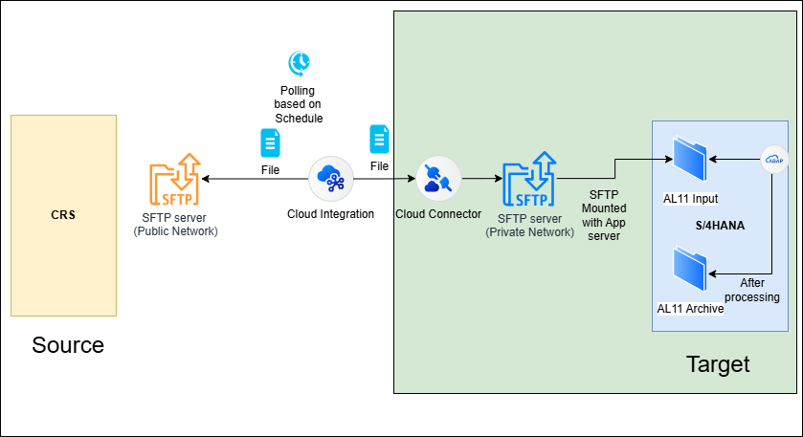

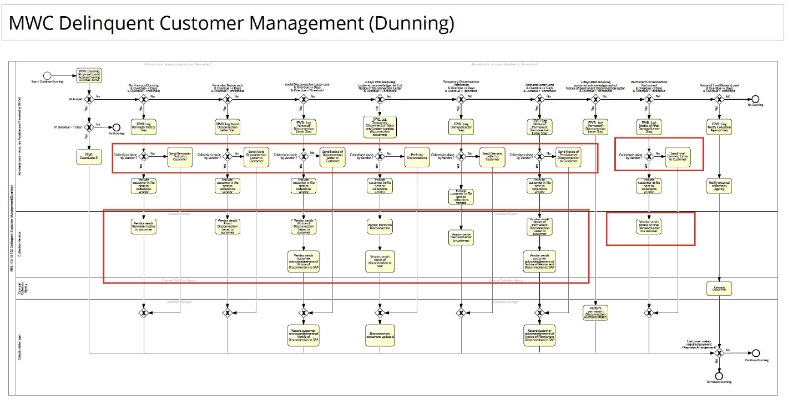

Initiating/Triggering Process
Interface Program/ Tcode is executed as per the batch schedule or on demand( To view/ Upload the created file)
The program will operate in three modes :
- Process File mode: Executed in background as a batch job
- Upload File Mode : Executed in foreground on an ad-hoc real time basis
- View File Mode : Executed in foreground on an ad-hoc real time basis

Key Considerations
- CPI will poll the files from the CRS SFTP server.
- The average file size is < 200 KB.

Security Requirements
- Inbound connection to the CRS server will be secured using SFTP connectivity.
- Cloud Connector is used to connect Cloud Integration with S/4HANA SFTP server. It acts as a secure reverse invoke proxy that enables controlled access from the cloud integration to S/4HANA without exposing the internal network directly to the internet.

Data Processing Requirements
- This will be a pass-through interface in CPI. That means there will be no processing of data within the CPI. It will pick the file from the MWC SFTP server and place the same file in the S/4HANA SFTP server.
- The Dunning Files will be available as .xlsx files

Program Attributes
Program title | Inbound Dunning Report
Program Name | ZAB_M2C_INBOUND_DUNNING
Program Type | Executable Program
Package | ZS4_MWC_M2C_FICA
Authorization Group | N/A
Type of Interface | Asynchronous
Mode of Execution | Background

Transaction Code | ZTR_INBOUND_DUNNING
Include Programs | zin_m2c_inbound_top.  zin_m2c_inbound_e01.  zin_m2c_inbound_f01.
Function Modules | N/A
Message Class | N/A

Classes | N/A
Generic Classes / Utility Classes | N/A
AMDP Classes | N/A
Proxy Class | N/A
FEH action class | N/A
Basic IDoc type | N/A
IDoc extension | N/A
Custom IDoc segment(s) | N/A
AIF Function module | N/A

Selection Screen
N/A
Parameter / Select Options | Type / Field Name | Mandatory | Default Value | Parameter  ID | Search Help | Selection Screen Text
P_BUKRS | BUKRS | Yes |  |  | Yes | Company Code
P_SCP | CHAR12 |  |  |  |  | Service Provider
P_DATE | SY-DATUM | Yes |  |  |  | Processing Date
RB1 | CHAR1 |  |  |  |  | Create File Mode
RB2 | CHAR1 |  |  |  |  | View File Mode
RB3 | CHAR1 |  |  |  |  | Update File Mode
P_FILE | LOCALFILE |  |  |  |  | Select File

Validation

Selection Criteria validations
Not Applicable

Interface parameter validations
Not Applicable

Other validations
Not Applicable

Authorization Requirements
Department /Roles within companies that will perform dunning activities must have Authorization to execute the custom t-code, access files in the application server and Upload files.

Definition
Not Applicable

Defined Fields
Not Applicable

Procedure
- Inputs fields on the selection screen.
- Based on the radio button selected, further processing is done.
- If create file mode radio button is selected then record is validated and the added to the log tables
- If view file mode radio button is selected, an alv is displayed and we can download the selected records.
- If the update file mode is selected, the uploaded file from local system is stored in AL11.

Technical Flow Diagram
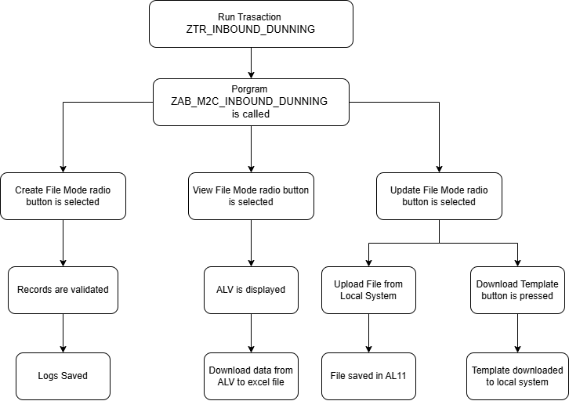

Processing Logic
- Create File Mode
- Reads the uploaded .xlsx file using cl_fdt_xl_spreadsheet.
- Stores the file contents into internal table gtt_create_table.
- Loops through each entry in gtt_create_table.
- For each record:
  - Validate the records based on various conditions.
  - If any validation fails the record is transferred to the error file in AL11.
- Concatenates each field of the record into a comma-separated string.
- Writes data into the archive file using TRANSFER.
- On successful validation record is modified in the tables fkkmako and zdt_m2c_disc
- Inserts a log record into ZDT_M2C_DUNFILE.
- Closes the archive dataset.
- Clears internal table gtt_create_table.
- View File Mode

- Performs SELECT from ZDT_M2C_DUNFILE using:
- Company code (P_BUKRS)
- Service provider (P_SCP)
- Populates internal table GT_OUTPUT with results.
- Calls f_display_alv to show records using REUSE_ALV_GRID_DISPLAY.
- ALV includes selectable rows with checkbox (SEL field).
- PF-STATUS includes a custom toolbar button: Download (&DWN).
- On pressing Download:
- Filters selected row(s) in GT_OUTPUT.
- If exactly one row selected:
  - Reads file paths from TVARVC for:
    - Input folder (Z_INDUNNINPUT)
    - Error folder (Z_INDUNNERROR)
    - Archive folder (Z_INDUNNARCHIVE)
  - Fetches path mapping from ZDT_M2C_DUNPATH.
- Processes each line into structured output for download.
- Calls f_download to generate .xlsx using CL_SALV_TABLE->TO_XML.
- Update File Mode

- Allows file selection via P_FILE.s
- When Upload button is pressed:
- Prompts user for confirmation using POPUP_TO_CONFIRM.
- If confirmed:
  - Uploads content via GUI_UPLOAD into internal table GT_DATA.
  - Writes uploaded content to staging folder (/staging/...xlsx) using TRANSFER.
- When Download Template is clicked:
- Asks user to choose download folder.
- Generates a .xls file using GUI_DOWNLOAD with:
  - Header: GT_HEADER_TABLE
  - Data: GTT_CREATE_TABLE

Validation
Not Applicable

Mapping
Not Applicable

Error Handling
Not Applicable

Custom DDIC Objects
Not Applicable

BRF+ Design
Not Applicable

Reusable Code
Not Applicable

File Attributes
File Type
Delimited / Fixed width | N/A
Header Record? | N/A
Footer Record? | N/A
Number of File Layouts and Description | N/A
File Layout(s) | N/A

Internal Tables
Not Applicable
Name | Description

Messages
Not Applicable

Message Class | Message ID | Message Text

Selection Text
Not Applicable
Name | Description

Text Elements
Not Applicable
Name | Text Description

Subroutines
Not Applicable

Name | Description

Interface List Output

Output Method
Not Applicable

Sub Heading
Not Applicable

Layout
Not Applicable

Totaling
Not Applicable

Sorting
Not Applicable

Page Break
Not Applicable

Error Handling
Not Applicable

Interface List Header & Footer
Not Applicable

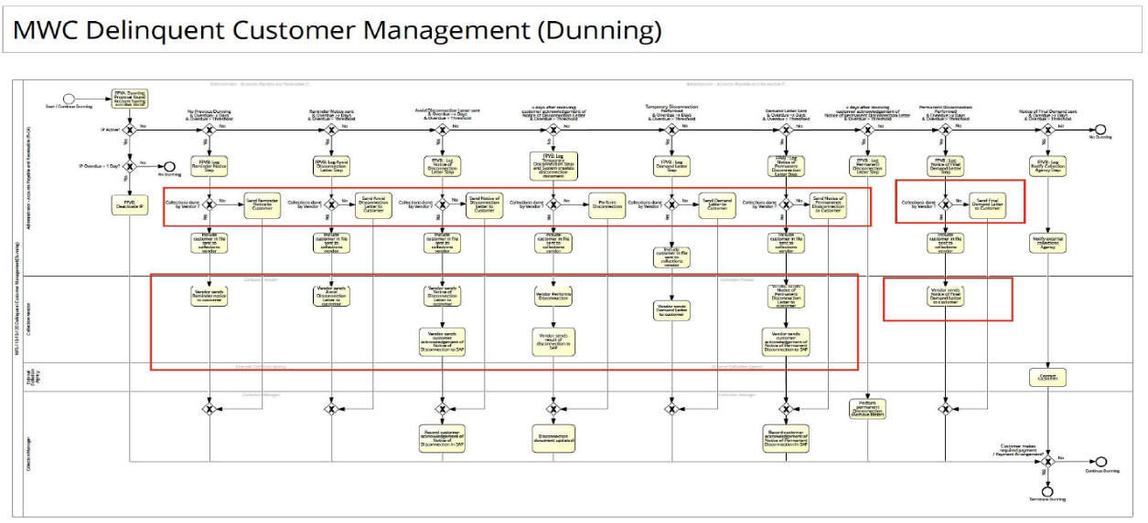
Technical Design of Integration Flow

System Overview

Source/Target System
- Receiving System: SAP S/4HANA
- Sending System: CRS SFTP
- Direction: Inbound

Source System
System Name | CRS SFTP
Type of system | Internal

Target System
System Name | S/4HANA
Type of system | Private Cloud

Configuration Details
- Channel and Adapter details would be used:

Connection 1: Sender Adapter
Channel Name | SFTP_SND_DunningFile
Adapter Type | SFTP
Transport Protocol | SFTP
Message Protocol | File
Source | Directory | /M2C/DunningAck/M001/
 | File Name | *Inbound Dunning Activity*.xlxs
 | Address | 120.28.45.179:6443
 | Proxy Type | Internet
 | Authentication | Username/Password
 | Credential Name | SFTP_Generic_UserCredentials
 | Timeout | 10000
Processing | Post Processing | DeleteFile
Usage | Connect CRS SFTP Server to SAP Cloud Integration

Connection 2 : Receiver Adapter 1
Channel Name | SFTP_RCV_DunningFIle
Adapter Type | SFTP
Transport Protocol | SFTP
Message Protocol | File
Target | Directory | /DS4/Inbound/Input/M2C/Dunning/${header.SubFolderPath}
 | File Name | ${property.newFilename}
 | Address | ds4.sin.sap.mwci.zone:22
 | Proxy Type | On-Premise
 | Authentication | User Name/Password
 | Credential Name | SFTP_DS4_UserCredentials
 | Timeout | 10000
Usage | Connect SAP Cloud Integration to S/4HANA SFTP Server

Connection 3 : Receiver Adapter 2
Channel Name | SFTP_RCV_Archive
Adapter Type | SFTP
Transport Protocol | SFTP
Message Protocol | File
Target | Directory | /DS4/Inbound/Input/M2C/Dunning/M001/${header.SubFolderPath}
 | File Name | ${property.newFilename}
 | Address | ds4.sin.sap.mwci.zone:22
 | Proxy Type | On-Premise
 | Authentication | User Name/Password
 | Credential Name | SFTP_DS4_UserCredentials
 | Timeout | 10000
Usage | Connect SAP Cloud Integration to S/4HANA SFTP Server

Interface Data

Interface type: (File)

The interface would be Asynchronous in nature.
- Interface Name : DID_M2C_138_CRS_to_S4HANA_HandleDunningFile
- Interface description : Inbound interface to handle file/notice sent by the service provider
or uploaded by an internal MWC user as part of Dunning Activity
- Interface design : File to File (Direction: Inbound)
- Involved Systems : CRS SFTP Server and S/4HANA
- Package : CRS Integration with SAP S4HANA

Interface Description

Interface Design

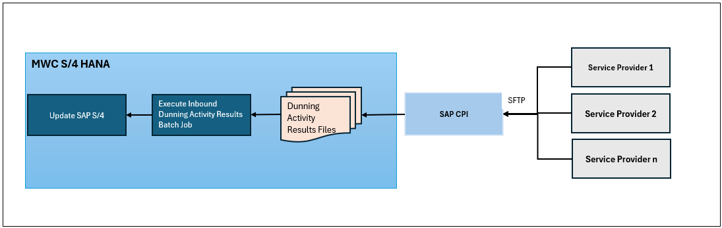

In general, the following functionality needs to be realized through I-flows in CPI:

Asynchronous design flow

S no. | Pre-processor functionality | Technical writeup
1 | CRS will place Dunning Files in the MWC SFTP Folder.
2 | CPI polls the Dunning Files from the MWC Folder at the prescribed time intervals | SFTP adapter is used to poll the files
3 | The Dunning Files are then pushed SFTP of S/4HANA | SFTP adapter is used to place files on SFTP S/4HANA
4 | In case of error, error logs will be available in the CPI monitoring | Exception Subprocess is used

Producer System Requirements
Transport Protocol - SFTP

Consumer System Requirements
Transport Protocol - SFTP

Transaction Volume
Daily Volume is expected to be in range of 50K~ to 60K~
Average Download File Size : 250KB

Technical Design Diagram

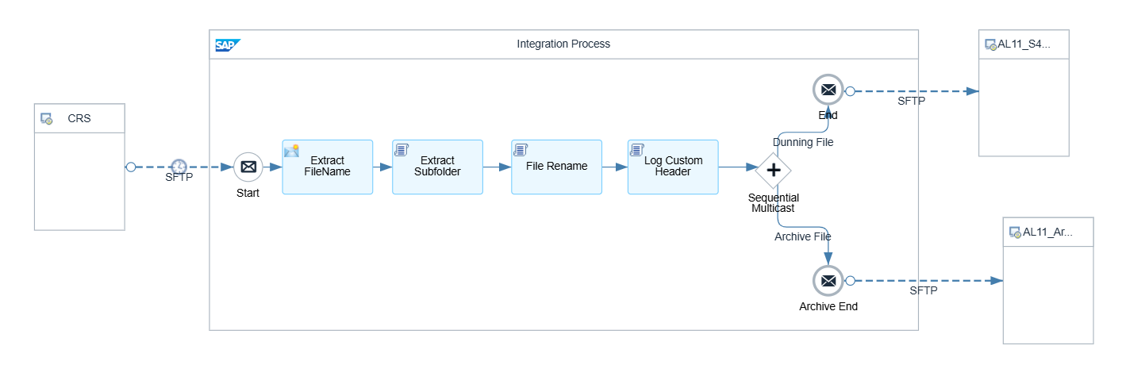

Monitoring
Cloud Integration standard monitoring dashboard can be used to monitor the iFlow.
The below custom headers are logged.

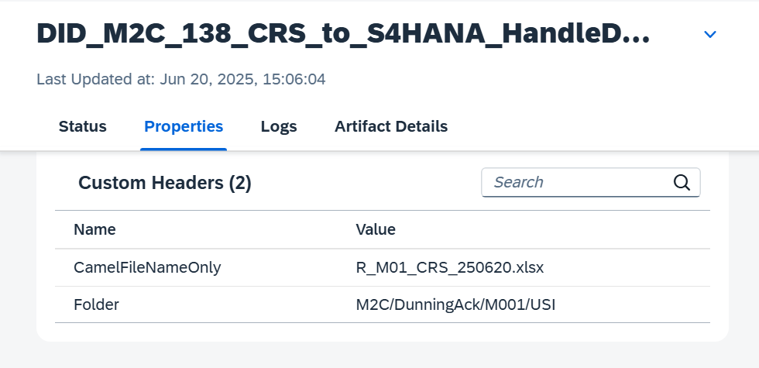

Other Process Parameters

Below are the external parameters configured in SCPI.

Parameter Name | Value | Description
Sender Adapter | SFTP | SFTP_SND_DunningFile
Directory | /M2C/DunningAck/M001/ | CRS_Directory
File Name | *Inbound Dunning Activity*.xlxs | Dunning_Filename
Address | ds4.sin.sap.mwci.zone:22 | CRS_Address
Authentication | User Name/Password | CRS_Authentication
Credential Name | SFTP_Generic_UserCredentials | CRS_Credentials
Timeout | 10000 | TimeOut
Processing | Post Processing | Delete File

Parameter Name | Value |  | Description
Receiver Adapter | SFTP | SFTP_RCV_DunningFile
Directory | /DS4/Inbound/Input/M2C/Dunning/${header.SubFolderPath} | AL11_Directory
Address | ds4.sin.sap.mwci.zone:22 | AL11_Address
Authentication | User Name/Password | Authentication
Credential Name | SFTP_DS4_UserCredentials | AL11_Credentials
Timeout | 10000 | TimeOut

Parameter Name | Value |  | Description
Receiver Adapter | SFTP | SFTP_RCV_Archive
Address | ds4.sin.sap.mwci.zone:22 | AL11_Address
Authentication | User Name/Password | Authentication
Credential Name | SFTP_DS4_UserCredentials | AL11_Credentials
Timeout | 10000 | TimeOut

Process Description
This is an asynchronous interface where MWC sends Dunning Files that has to be placed on SAP S/4HANA at specified intervals

Execution Instruction
- File format and its field mapping and acceptance logic from Service providers must be accepted and confirmed.
- Dunning Activity file must be received by the service provider /inhouse collections team and the activity mentioned in the file must be executed / attempted to be executed before executing this process

Extracting Data from the Producer
N/A

Mapping
As this is a pass-through scenario, there is no mapping involved.

Data Processing
N/A

Data Input at Consumer
N/A

Transfer Files
The .xlsx files will be transferred

Exception Handling

- Errors encountered during batch processing must be logged in job/SLG1 logs.
- Errors encountered during the foreground processing must show messages as mentioned in in Section 3.1 Processing Logic section
- Errors during file transfer through SFTP will be handled by CPI exception handling

Retry Mechanism (If Applicable)
In case of any failure on SCPI end, reconnect attempts would be made.

Assumptions in Technical Design
- The file format is the same for all ISU companies.
- The dunning activity File created will be saved on path i.e. provided on batch schedule run.
- One dunning activity File will be sent by services providers or uploaded by inhouse collections team each day.
- If no dunning activities are performed on a given day, then the service providers / inhouse collection team will not send/upload any file.
- For processing of the file , the Interface program/T.code must always be executed in batch processing mode(background).
- Only one file per day will be received for each company code / service provider combination (In case the company performs the dunning activity in house then only one file per day will be uploaded.)
The file will include results of Temporary Disconnection requests as well as acknowledgement of dunning letters/notices

Open Issues in Technical Design
Not Applicable

Unit Test Results

Scenario # | Input Selection Criteria | Expected Result | Actual Test Pass/Fail
1 | Process results of accounts belonging to M001 with the following collection steps:  C001 Reminder Letter  C002 Avoid Disconnection Letter  C003 Notice of Disconnection Letter  C004 Notice of Disconnection Letter - II  C005 Temporary Disconnection  C006 Meter Pullout  C007 Notice of Permanent Disconnection  C008 Notice of Final Demand Letter  C011 Demand Letter  Execute Intbound dunning activity file Batch Job | All files that were sent by different service providers for M001 . were processed  The custom dunning log table and dunning header table and EDISCDOC table were updated correctly  The files were moved to the correct archive folder . | Choose an item.
2 | No inbound dunning results file with wrong filename/ filetype stored in the inbound folder  Execute Inbound dunning activity file Batch Job | File must not be processed . | Choose an item.
3 | No inbound dunning results file present in M001 inbound folder  Execute Inbound dunning activity file Batch Job | No action – no updates . | Choose an item.
4 | User has Temporary Disconnection results file for accounts belonging to Ccode that performs activities in house .  Upload the file using the Inbound dunning activity custom T-code  Execute Inbound dunning activity file Batch Job to process the uploaded file | The file was uploaded successfully and processed  The custom dunning log table and dunning header table and EDISCDOC table were updated correctly  The processed files were moved to the correct archive folder .
5 | Download files created through the “View Files” mode in the custom t-code | User is able to view file details, select the file and then download the file to his/her local system .  The dunning log table is updated correctly ( last accessed by / on )
6 | Attempt to download files that are not yet created through the “View Files” mode in the custom t-code | System shows message: “Selected file could not be found or is deleted”.

Related Documentation
Not Applicable

